**Presentation**

This article's originality resides in the following four points:

 1) It breaks a new path in Public Finance analysis, since it is the only model (I know of) that fits all of Public Finance: Income, Expenses and Debt compressed into two state variables: Debt and Income, and three growth parameters, one for each of the three variables. Models on Public Finance have taken the route of relating these variables to GDP, losing the possibility of integrating these variables as this article has done.

 2) Although data is fitted to the model, it is really not an econometric model, but rather a mathematical one. The arrangement is also one of public finance accounting. To my mind, this tightens up the analysis.

 3) The article establishes regions and zones of Financial (and Political) Sustainability, as is shown in the case of Mexican Public Finance. So, it is a practical tool for checking on movements towards (or away from) Sustainability. I hope this would be clear from the several examples I develop.

 4) Currently, the prevailing theory that dominates models of Public Finance, and more importantly its practice, establishes that Budget Surpluses are the road to Sustainability. This article shows how this is not true, requiring a simultaneous evaluation of the entire model developed in the article.

**An Integral Model of Sustainable Public Finance**

**by**

**Firdaus Jhabvala**

1. **Introduction.**

When I began thinking about the problem of sustainability of Debt for any entity, private or public, but especially for national governments, I decided to divide my goal into two smaller and closely linked goals: first, establish an integral model of finance in general, and public finance in particular; and second, fill up the model with what strictly needs to be in it, eliminating all else from the purview of the model, as for example the productivity of Debt, a very important point for me, but one on which entities, private and public, generally do not want to be bothered with, and therefore we have poor and erratic information on this point and so I have left it out of the model that is being presented here.

In the above endeavor, I sought the help of a logician, Alfred Tarski.[1]

In our proposed mathematical model of two differential equations, we hope to comply with Tarski’s two requirements.

First, in terms of consistency, we find no contradiction between the two equations (I) and (II) set up in Section III of this article. Second, our model is complete, since it includes the three branches of Public Finance (Income, Expense and Debt), and includes no other concept that does not directly come from them. Thus, we do not consider GDP as an acceptable state variable for our model, since it is outside of the purview of Public Finance, i.e., however important GDP may be to the economy as a whole, it is not within the set of concepts that constitute Public Finance. This is an important point that I would like to develop somewhat.

Governments tap into GDP to get their Income. It is true that there is, in the absence of good fiscal reform or collapse, an elevated correlation between Government Income and GDP. But putting GDP into a model of Public Finance destroys the requirement of completeness of the model, since non-fiscal elements (the great majority) of GDP would now find their way, through this back door, into a model of Public Finance. More importantly, an integral model of Public Finance, with interrelations only between the three branches of Public Finance, would be impossible, and we would have to recur to econometric estimates at every stage of our work, instead of mathematical certainty, a clear loss in precision. Third, the results of the model would be expressed only in terms of the three state variables we have set up, each one representing an entire branch of Public Finance, a big advantage in terms of exercising control or oversight over any of them. Finally, if GDP were to be included in our model in place of Income, simplicity would be sacrificed, as the reader may hopefully agree after going through this article.

It is worth noting that in a wide-ranging and complete evaluation of sustainability indicators, the Primary Gap is deemed the best.[2] However, to our mind, its dependence on GDP reduces its utility, especially in times of economic crisis, when the political response to the crisis could be anything from increasing the Primary Gap to reducing it. We may add that the external pressures add to the internal ones in making this strategic decision very political and not so much financial. Thus, GDP and Public Finance may probably part ways until some form of stability is restored.

Thus, this article's originality resides in the following four points:

 1) It breaks a new path in Public Finance analysis, since it is the only model (I know of) that fits all of Public Finance: Income, Expenses and Debt compressed into two state variables: Debt and Income, and three growth parameters, one for each of the three variables. Models on Public Finance have taken the route of relating these variables to GDP, losing the possibility of integrating these variables as this article has done.

 2) Although data is fitted to the model, it is really not an econometric model, but rather a mathematical one. The arrangement is also one of public finance accounting. To my mind, this tightens up the analysis.

 3) The article establishes regions and zones of Financial (and Political) Sustainability, as is shown in the case of Mexican Public Finance. So, it is a practical tool for checking on movements towards (or away from) Sustainability. I hope this would be clear from the several examples I develop.

 4) Currently, the prevailing theory that dominates models of Public Finance, and more importantly its practice, establishes that Budget Surpluses are the road to Sustainability. This article shows how this is not true, requiring a simultaneous evaluation of the entire model developed in the article.

1. **Our objective.**

**II.A The theoretical model.**

For us, Financial Sustainability for a Government is defined as its ability to achieve its goal of keeping the real Debt/Income ratio under or at an objective and previously fixed Debt/Income ratio. By “objective” I mean subject to the best financial practices in operation.

The Model could be calibrated with data from a Ministry of Finance, as we have done in Section V of this article, in an additional effort to order the Indebtedness in favor of healthy and sustainable federal finances, and not as before, merely borrowing up to the limit of the guarantees acceptable to its creditors, a policy that would turn any government into a simple payer of the yields on its Debt as its main if not only task, obviously without the capacity to attend to the needs of the People.

For many reasons, the final financial balance is seen most clearly in the behavior of Debt in relation to Income, Expense being subsumed in our analysis by recognizing Primary Surplus as a variable that includes Total Expense, and in what follows, we are going to link with Income as a percentage that effectively affects the rate of growth of Debt. This linking of non-financial Expense, that is, all Expense except that part coming from the Debt, or going into the Debt, with Income through the Primary Surplus, allows us to drop the Expense variable from direct analysis and relegate it to indirect analysis, and so we are able to work with only two variables, Income and Debt, non-financial Expense being linked to Income and so participating completely in the model even though it does not appear in our two differential equations. Naturally, real accounting practices may make our data requirements somewhat harder to get in certain situations, but that is a problem we deal with in a pair of examples in the next section of this article.

**II.B Our state variables.**

There are several state variables in Public Finance. Most of the important ones are: Income, Primary Expenses, Financial Cost, Expenses, Budget Surplus, Debt and Newly Contracted Debt. However,

(i) Expenses = Primary Expenses + Financial Cost; and

(ii) Budget Surplus = Income – Primary Expenses.

These two equations reduce the model to five remaining state variables: Income, Financial Cost, Budget Surplus, Newly Contracted Debt, and Debt. But,

(iii) Increase in Debt = Newly Contracted Debt – Budget Surplus + Financial Cost,

since we assign Financial Cost to the Debt accounting, and not to the Expense accounting which can now be eliminated from the model. Equation (iii) allows us to solve out for Newly Contracted Debt, or as we do in the article, get the information on Increase in Debt and subsume Newly Contracted Debt in it. Thus, we finally have four state variables left: Income, Financial Cost, Budget Surplus, and Debt.

Now, we add in another equation, with a new parameter, b:

(iv) Budget Surplus = b Income.

So, instead of Budget Surplus as a state variable, we have a relation b, a parameter that allows us to reduce the number of state variables in the model. Of course, b could easily be reconverted into a variable, especially over time, as could be the other two parameters, g and r, measuring growth of the state variables, Income and Debt respectively.

Finally, Financial Cost can also be discarded as a state variable, since (by equation (i)), it is Expenses – Primary Expenses.

This leaves us with the two state variables of our model (Income and Debt) and the three parameters that could eventually be turned into variables (especially of time).

I understand that the subject is difficult and complicated. I don't have the Truth on the subject. But, as an economist, I consider that my obligation is to seek the beginning of a fruitful dialogue with positive people on the firm foundations of Economic Theory on a subject that forms the heart of all the efforts that peoples everywhere make every day in the hope of receiving from the collective part (mainly governmental) a positive response to their aspirations. The act of ordering Public Finance surely must start with a clear statement of Financial Sustainability. Hence, the importance of our model.

**II.C The Equations.**

We start with a simple growth equation:

Y’ = (g + b)Y (I)

where:

Y = Income,

Y' is the derivative of Y with respect to time,

g = the growth rate of Income before accounting for the effect of Debt; and

b = the part of the Income used to pay the Public Debt (b < 0), or the part of the Income received with external funds, and charged to that Debt (b > 0). Thus, b represents the transfer between Income and Debt. At a time that we now consider past, it was mostly always positive, contributing external resources to the government economy, but at the same time increasing the Debt. Thus, also, bY is the Primary Surplus (or Deficit), dedicated to paying a part of the Financial Cost of Debt (or increasing it). The Government has to guess correctly whether an additional expense (current or capital), created with extra Debt would be better for its future sustainability than not going through with the operation and holding the Debt constant.

Essentially, the question becomes which would grow faster: Debt or Income? With some sizeable existing Debt, the government’s future financial capacity depends upon it having a present and future constant and sizeable stream of Primary Surplus. Too many governments overestimate their real possibilities of the income (and expense) option, that is, a current solution to a current situation, and go for the debt option, creating a problem of sustainability further down the road.

So, what we are saying is that contracted Debt should be productive and not automatic deficit-filling unproductive Debt, as an irreflexive answer to poor Expense management. The guardrails against unproductive Debt are weak everywhere, oftentimes non-existent, and governments do not want, for many reasons, to say what part of contracted Debt is being paid off by the relevant projects that absorbed that Debt. Democracy should work towards the strengthening of these guardrails, especially in this matter of productive indebtedness.

In order to have Sustainable Finance, many countries, such as Mexico, Hungary and many others, need to meet the condition of having b chronically negative, that is, devoting a part of the Public Income to the payment of the Debt. Now, b could vary over time, b(t). It could eventually evolve into a control variable in an optimal control model, something we have not done here, since we believe there are a host of other issues to clean up before we get there. Our model shows the high degree of sensitivity of Public Finance to small movements in b, making it a critical control variable for the entire model. Here, more is not the same as better, as our model will show, and as we should expect, from the concave nature of most economic and financial functions.

The second equation establishes the rules for the growth of Debt, and relates the growth of Debt, D, to Income, Y, through transfers between (D, Y):

D’ = rD + bY (II)

The growth of Debt without any interaction with Income gives us the average rate of return, r, on all existing Debt. This may be in the form of interest, commissions, other fees, devaluations of the local currency, corruption, theft, or any other cause that finds its way into existing Debt. This is a different procedure than the normal simple (partial) accounting of interest (and accessories such as commissions) as return over Debt. We take into account an increase in Debt over the same period, and the parameter r reflects this increase, which of course includes the return on Debt plus any other factors contributing to its increase over the period in question.

We are also assuming something else: contracting (or crediting a payment to) an amount of new Debt results in an equal increase (or decrease) in Income, that is, the contracted amount enters fully into Income and is not subject to discounts, legal or illegal, of any nature. Normally, it is like that and economic and fiscal accounting do it that way. Otherwise, we would have to add an additional parameter h for discounting bY when it affects Income positively and/or increasing bY when it affects Income negatively, inefficiency always working against the public weal. The parameter h would therefore become an inefficiency factor, akin to a corruption index. In our case, we have treated it as unity, mostly because we do not have good data on the parameter, something that would certainly be a worthwhile study in itself.

1. **Our Method**

Having set up our theoretical model in Section II, we now establish our method for analyzing it for Sustainability.

Our greatest interest is in knowing the evolution of the relationship between Debt and Income, defined as W ≡ D/Y for different scenarios of the variables (r, g, b). Let us remember that r is not the contracted interest rate, but the rate of growth of D before including payments bY, and therefore an amount generally greater than the interest generated.

So, we have Equation (III), which specifies the rate of change of the D/Y ratio over time, and will be central to the discussion that follows.

W’/W = r + b/W – (g + b) (III)

The first two terms on the right-hand side of (III) reveal the Debt effect on the rate of change of W, and the last term the Income effect.

Equation (III) could be multiplied by W to yield

W’ = aW + b (IIIA)

where a is (r - g - b).

First, if we take (a, b) as constants, (IIIA) yields[3]

W = -b/a +c exp(at) (IIIB)

Where c is the constant of integration and can be solved out for any boundary condition, such as W(0) = W0 > 0, so that

c = W0 +b/a.

There are many paths that W could take depending upon the sign and size of (a, b). If (a, b) > 0, then W tends (with t) to ∞. If a > 0 > b, then W tends to +/- ∞ according to the sign of c. If a < 0, regardless of the signs of b or c, W tends to -b/a. The typical case is the intermediate one, with r outstripping (g + b) and b negative.

We now show examples of how our model could be applied to Financial (Debt) Sustainability.

**IV Results**

**IV.A Theoretical results**

The first result we want to find is the combination of parameters (r, g, b) that leaves the D/Y ratio constant, that is, W' = 0, from which:

W* = b/(g + b – r) (IV)

Equation (IV) establishes the borderline between Financial Non-Sustainability and Financial Sustainability at the current (or objective) D/Y ratio, W*, critical to the health of the entire government economy. For example, for W* = 2, as has been approximately the case in Mexico for the past few years, and is an approximate figure for many countries, we will have

b = 2(r – g) (IVa)

Therefore, to keep the Debt/Income ratio at 2, Mexico would need b to be twice (r – g). If r = 8%, g = 6%, we will have b = +4% of Income, that is, a Primary Deficit of 4%, through infusion of Debt, is required to keep Income growing at the same rate as Debt, a policy followed by the country with terrible effects, basically due to its system of contracting unproductive Debt as the final event of improperly managed Public Finances, with the resulting model yielding, at times of crisis, an interest rate on Sovereign Debt of up to 18% per year. Therefore, if in the next period, r is greater, say 9%, or g is lower, say 5%, we would need a Primary Deficit of 6% of Revenues, and so on, until the federal finances are ruined in the effort to maintain Debt in a fixed relationship with Income, and then simply to count on some minuscule increase in Income, that is, economic exhaustion.

Now, with (r – g) negative, with (say) r = 8%, g = 9%, b = -2% of Income, we will have a reduced Primary Surplus that does not make the growth rate of Income depend on new Debt, and it allows for a lasting solution not only for W* = 2, but also for the rest of the government economy. If b is now controlled to become (say) -3%, from equation (IV) W* = 1.5, well towards Financial Sustainability, if the parameters hold, especially politically speaking. The political authority could choose, between these two alternatives, or positions in between.

From equation (IV) it is evident that when (r > g), b has to compensate for the lack of Income generated within the government economy to achieve the goal of keeping W* constant. Of course, when (g > r), there is no such need, and with (b = 0), that is Zero Deficit, the W* ratio goes down, there is even room to contract more Debt through a Primary Deficit. The superiority of g over r is then critical for Sustainability, although some regimes with (g < r) are also sustainable.

In this sense, with flourishing and dynamic revenues, almost the entire Public Indebtedness problem is reduced to one of optimal control of parameter b. Therefore, the aeration of the national collection system should be a high priority to raise the parameter g to at least approach r, enough to solve the most urgent part of the problem of Public Indebtedness in the medium term.

Also, it is critical for a country to pay much attention to the development of its capital markets, as Ronald McKinnon established some five decades ago.[4] The relatively poor attention given to these internal markets makes these countries depend excessively upon foreign markets, often times starting off a major devaluation crisis that periodically blows up the foreign component of Public Debt.

We now establish Financial Sustainability Zones that can be crossed with Political Sustainability Zones (for example, Min b < -3%) to establish the acceptable area for Public Finances, through two comparisons: first, a scheme such as Graph 1, essentially valid for low-debt countries, with another for medium to high-debt countries (Graph 2).

Graph 1.

(r – g), b, for W* = 2

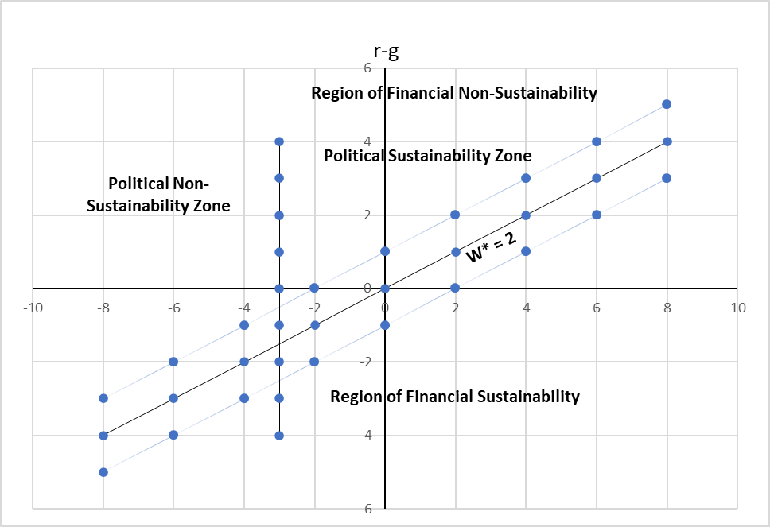

To the right of the diagonal line is the Region of Financial Sustainability (W' < 0), and to the left of said line is the Region of Financial Non-Sustainability (W' > 0), both regions separated by W' = 0 and W* = 2. There is also a Political Sustainability Zone that we mark to the right of the point (b = -3%). Of course, a successful policy would achieve a point that meets both the Political and Financial requirements. For another W*, say W^, a W that we want, there would be another region of sustainability. As W goes down, these Debt to Income proportionality W* lines turn clockwise, and W* = 1 lies on top of the x axis. Also, we have marked a financially comfortable region as a band around W* = 2. To the northeast of the band Sustainability becomes increasingly risky, and W slides into territory greater than W*. To the southwest of the Sustainability band, W drops under W*, and if this regime could be maintained, W* could be lowered accordingly.

Now, we will present another happier scheme with W* = 0.5, to show the increasing options for not carrying a heavy Debt relative to Income, which can be achieved with (r – g) = 2 % per year, and with b < -2%, perhaps -2.5%, very close to the limit of the Political Sustainability Zone.

Graph 2.

(r – g), b, for W* = 0.5

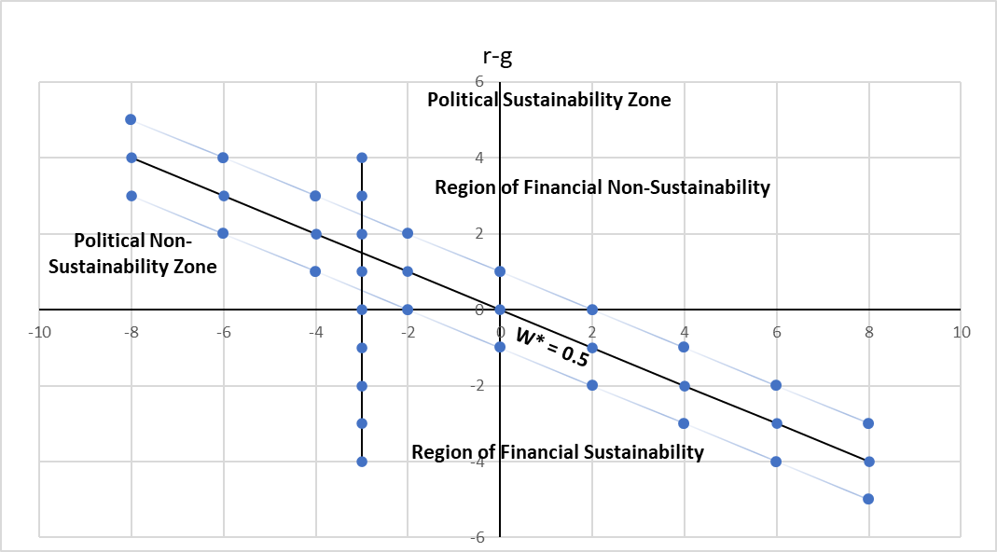

As W is reduced, the emphasis of the model is transferred from the management of the parameter b to the reduction of (r – g) and its eventual conversion into negative quantities permanently, an objective achieved by the financially developed countries, which can thus have virtually any W for having the parameter r very close to zero. But this is not so for less developed economies that have to keep their growth rate of Income high enough to be in the neighborhood of r. Therefore, comparing the financial circumstances of these with developed economies, on the basis of direct Debt/GDP ratios, for me is a serious mistake.

**IV. B Empirical results**

In Table 1, we have put together data for Public Finance for Mexico’s entire Federal Public Sector for the period 1996-2021. We need two years for calculating each of our three parameters, (r, g, b), so we have no results for the first year, 1996.

Table 1 (Part 1)

Data for the entire Mexican Federal Public Sector, 1996-2021 (in millions of pesos)



Table 1 (Part 2)

Data for the entire Mexican Federal Public Sector, 1996-2021 (in millions of pesos)



In Table 1, we have brought together the main data for Mexico’s Federal Public Sector, and some observations are in order:

1. Income is Gross Income. Naturally, some of the Income for Public Entities is transferred (through taxes, fees and so forth) to the Federal Government which also registers it as Income. So, the Income total may be somewhat different utilizing a different criterion for cancelling out these transfers.
2. Primary Expenses have (after 2013) been specified in the Public Accounts, but before then were not presented as such. Rather I have had to deduct Financial Cost from Total Expense to get the numbers for Primary Expense.
3. Debt is at year end and is Gross Debt.
4. Financial Cost has been calculated by me in the period 1996-2012, since it was not specified as a concept, but as part of Non-Programmable Expenses, including Participations (Revenue Sharing) under that heading.

The first data that is of interest to us is the path of b over the entire data period.

1. From 2000 through to 2008 we observe huge Primary Surpluses every year, an average of almost 9%. Did these huge surpluses drive down the amount of Debt, or at least the D/Y ratio? Debt increased almost as fast as Income in the period, so that D/Y was actually somewhat lower in 2008 than in 2000. Financial Costs increased much more slowly than Income or Debt, indicating a favorable time for generally lower interest rates relative to Income growth (g > r). But at the end of the period, the reverse is true, (r > g) for 2008, and the problem was already out of hand, since with those data, D/Y tended to grow at an annual rate of 14.29% (see column [15]), a sure sign of what was in store for Mexico’s Public Finances for 2009, when D/Y explodes to 1.47, initiating a new era of significantly increased indebtedness, and a corresponding reduction of margins of maneuver for Public Finance, a handicap for the country that only increased with time.
2. From 2008 through to 2018 we see a sustained and high increase in the Debt/Income ratio, from 1.14 to 2.15, and (r > g) in a large way, barring three years when the difference between r and g was less than 2 percentage points, which we take as a general criterion of nearness to Sustainability.
3. From 2018 to 2021, we have a small rise in the D/Y ratio, but the tendency is clearly upwards. New data for 2022 may alter this tendency, but in no way may we conclude that Mexico’s Public Finances are out of the woods.

Our second data of interest is r, which also varies widely over the period, from 1% to 35% (column [9]), and fluctuates depending upon several factors, especially devaluations of the peso (2006, 2008, 2020, and the extended period 2014-2017). These devaluations increased the amount (in pesos) of external debt and so raise r, oftentimes in a very important way, making the path to Sustainability difficult. The lack of development of the different national (and especially, regional and local) capital markets is key for national development and also Financial Sustainability. In our way of thinking, it makes no sense to make the public entities borrow almost entirely on the international market at ever-worsening conditions. Of course, a part of the devaluation is recovered through increased Income, but (r > g) in all these years, sometimes to the tune of 28 percentage points as in 2009, in the aftermath of the devaluation the year before.

Our third data of great interest is g. In column [10] we calculate (g + b) as the annual increase of Gross Income Y, which is shown in column [10], and includes transfers from Income to and from Debt. In column [11], we then calculate g.

On the basis of very different policies for b, we have elaborated three periods: first, from 1997 through 2007; then, from 2008 till 2018; and finally, the last three years in our data, 2019-2021. In the first period, b was substantially negative with large Primary Surpluses; in the second period, b was considerably positive with large Primary Deficits; and in the final period, b is closer to zero than in the other two periods, although slightly negative. We analyze these three periods in Graphs 3, 4 and 5 respectively.

Graph 3

(r – g) and b for 1997-2007, with W* = 1.17

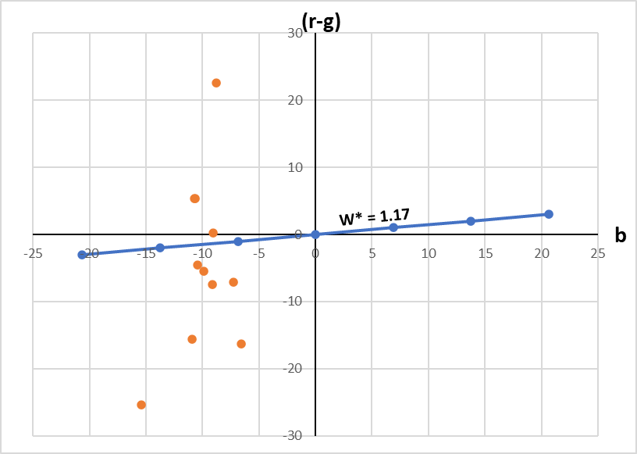

In Graph 3, the average W for the period is W* = 1.17, shown as the blue line. To its Southeast is the Region of Financial Sustainability. On it, W would continue to be 1.17 for the subsequent year(s). As the reader can appreciate, in the period, all the points lie between b < -5 and b > -16, that is, massive Primary Surpluses in every year. From Table 1, the reader may see that (r – g) moves steadily upwards throughout this period, so that we may conclude that, relative to the growth of Debt, Income growth was steadily diminishing. The investment of a part of the Primary Surplus of the period in Infrastructure or Services would have allowed (b + g) to be somewhat greater and (r – g) to be somewhat more reduced. From 2002 to 2007, in every year, the Primary Surplus was at least 9%, an average of 10%. Yet, at the end of the period, even with that kind of a Surplus, the Public Sector’s Finances were clearly outside of the Region of Financial Sustainability. And after years of large Primary Surpluses, both the Federal economy and also the National economy went into reverse gear.

We conclude from the data and our analysis that huge Primary Surpluses lead to Financial Unsustainability. Simply put, more is not better.

We now analyze the period from 2008 through 2018, characterized by large Primary Deficits.

Graph 4

(r – g) and b for 2008-2018, with W* = 1.71

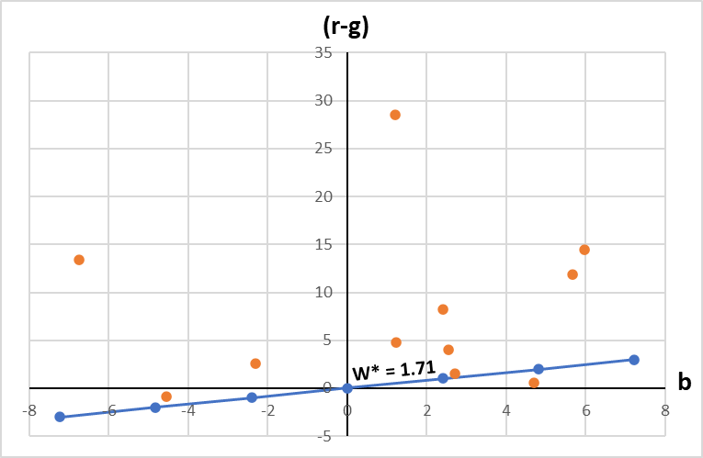

In Graph 4, we see a total reversal of the financial policy of the period 1997-2007, and b turns positive and in 6 of the 11 years, is greater than 2%. The average Debt/Income ratio, W, rises from 1.17 in the first period to 1.71 in the second. Only one of the 11 points makes it into the Region of Financial Sustainability, and two more are close by. Similarly, (r – g) is greater than 2% in 8 years. Spending most of the period solidly locked into the Region of Financial Unsustainability is a sure formula for ruining Federal finances.

Finally, in Graph 5, we look at the most recent period (2019-2021), where both (r – g) and b move towards the line of Financial Sustainability. This is much better than having huge primary Surpluses or Deficits, but it does not clearly get a handle on the financial problem. Nevertheless, the combination of (r – g) and b is much more in tune with what our model requires, which is basically stipulated in our Graph 1.

In Graph 5, the reader may observe that (r – g) is dangerously high (almost 10%) in one of the three years, and at that level of (r – g) Sustainability exists only with Primary Deficits of more than 18%. No amount of Primary Surplus moves the Federal Public Economy closer to Sustainability, but rather away from Sustainability. On the other hand, in the other two years, (r – g) is negative, allowing for a wide selection of Primary Deficits and Surpluses. The important point is to place the Federal Economy in the vicinity of the line marked W* = 2.24, preferably under it. Every year that this is achieved, W* for the next year is lower than the prevailing W*. With an annual reduction of W* by around 0.05, something already achieved in two of the three years in our data, in 25 years W* would be around unity, Debt would be a small drag on the Federal Economy, and it would not be broken by a Debt crisis.

Graph 5.

(r – g) and b for 2019-2021, with W* = 2.24

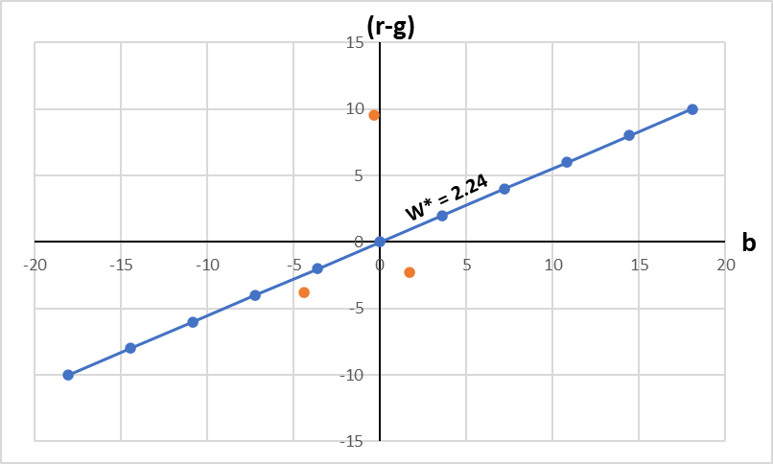

We have calculated the Correlation Coefficients for the data for the entire period (1997-2021) in Table 2.

Table 2

Correlation Coefficients for the data in Table 1

r (b + g) g W (r – g) W’/W

b .3630* .6309*** .8519** -.7747*** -.5573*** .4122**

r .2566 .3943** -.4540** .4062** .4674**

(b + g) .8981*** .4908*** -.6882*** -.6729***

g -.6230*** -.6796 *** -.6216***

W .2570 .2407

(r – g) .9913***

Note: For the two-tailed test of significance, we have 90% probability if the Correlation Coefficient is absolutely greater than .323, 95% if it is greater than .381, and 99% if greater than .487.

A first conclusion for our data series of 25 years, is that all coefficients are generally high: everything is closely related. This is as it should be due to the integral nature of public finance, recognized by our two differential equations, which cover its three main areas: Income, Expense and Debt.

A second conclusion, for the management of the Primary Surplus, is its consistently negative effect on important parts of Mexican Public Finance. This effect is greatly related to the growth rate of Income, g, and lesser so in lowering the rate of increase of Debt, r, so that overall, b correlates well with (r – g), big surpluses pushing Mexican Public Finance towards Unsustainability. This can also be seen in its relationship to both, W and W’, large negative b in the early 2000s going with low W and W’ also. But even in general, over the entire period, b correlates with the relative increase of W: large b (Primary Deficits) raising the rate of growth of W, and making Mexico’s finances that much unsustainable. Our model and the data recommend that Mexico should stay away from large Primary Surpluses, unless they be extraordinary and unexpected windfalls that naturally need time to be well utilized.

A third conclusion for the rate of growth of Debt without Income transfers, r, is well correlated with both g as well as (r – g), all moving together at different speeds. We also have r negatively correlated with W as a result of high r (compensated by high levels of b) in the early period up to 2007. However, r has a higher correlation with the percentage increase of W (W’/W) than b, but much lower than g. This points to our insistence on a faster development of a larger, more competitive national (not just metropolitan) capital market, and the movement of international debt towards this market, coupled with fast growth of Income.

A fourth conclusion is that the growth rate of Income, g, correlates well with (r – g). However, if all three variables (b, r, g) are increased proportionately, we may expect (r – g) to also increase. The correlation between g and W is very good, and for decreasing the rate of growth of W (W’/W), g is better correlated than r. For Sustainability, g is clearly the best alternative, superior to both b and r.

**VI. Conclusions.**

The indebtedness model was created by us in the eighties of the past century and published in 1991[5], and was initially used to determine the National Economic Sustainability Zones and then applied to the international negotiation of Mexico's Foreign Debt.

However, we have adapted that model to Mexico’s Public Finance. The model could be used to measure Sustainability for a country, state, municipality, corporation or any other entity that relies on Income, Expenses and Debt to convey its financial position. We consider it useful to include all the relevant variables and parameters in a single, easily managed, theoretical and practical model, to place any institution, public or private, in its corresponding Financial Sustainability Region.

My greatest hope is that, after due review, with important corrections, criticisms and modifications, governments would give the model an appropriate use.

1. See his book on the subject, “Introduction to Logic and to the Methodology of Deductive Sciences”, Dover Publications, Inc., 1961 reprint of the original text of 1941, p. 135, especially his two conditions (consistency and completeness) detailed in Chapter VI, “On the Deductive Method”, in preparation for the Second Part of the book, “APPLICATIONS OF LOGIC AND METHODOLOGY IN CONSTRUCTING MATHEMATICAL THEORIES”.
2. “The Forecasting Capacity of Indicators Measuring Budget Sustainability” by Csaba G. Tóth, Public Finance Quarterly, December 2014.
3. For confirmation, see for example Erwin Kreyszig, “Advanced Engineering Mathematics”, John Wiley and Sons, Inc., New York, 1962, Section I.7 on first order differential equations with constant and variable coefficients.
4. Ronald I. McKinnon, “Dinero y capital en el desarrollo económico”, CEMLA, México, D.F., 1974, translated into Spanish from his Brookings publication of 1973, “Money and Capital in Economic Development”, especially pages 18-23 that discuss the importance of high interest rates and the debt coefficient.
5. https://estudioseconomicos.colmex.mx/archivo/EstudiosEconomicos1991/211-230.pdf.